

OPERATING SYSTEMS
ASSIGNMENT 2

GROUP MEMBERS
ATIF SHAHBAZ AHMAD NOOR-UL-MEAN
L1F23BSEE0170 L1F23BSSE0180

SECTION SEE6

SUBITTED TO
SIR NAUMAN MAZHAR

QUESTION # 1
#include <iostream>
#include <pthread.h>
using namespace std;

void* factorial(void* arg)
{
int n = *(int*)arg;
int* fact = new int;
*fact = 1;

for (int i = 1; i <= n; i++)
*fact = (*fact) * i;

pthread_exit((void*)fact);
}

int main()
{
pthread_t t1, t2, t3, t4;

int a = 4, b = 5, c = 6, d = 7;
int *r1, *r2, *r3, *r4;

pthread_create(&t1, NULL, factorial, &a);
pthread_create(&t2, NULL, factorial, &b);
pthread_create(&t3, NULL, factorial, &c);
pthread_create(&t4, NULL, factorial, &d);

pthread_join(t1, (void**)&r1);
pthread_join(t2, (void**)&r2);
pthread_join(t3, (void**)&r3);
pthread_join(t4, (void**)&r4);

cout << "Factorial of 4 = " << *r1 << endl;
cout << "Factorial of 5 = " << *r2 << endl;
cout << "Factorial of 6 = " << *r3 << endl;
cout << "Factorial of 7 = " << *r4 << endl;

delete r1;
delete r2;
delete r3;
delete r4;

return 0;
}

OUTPUT
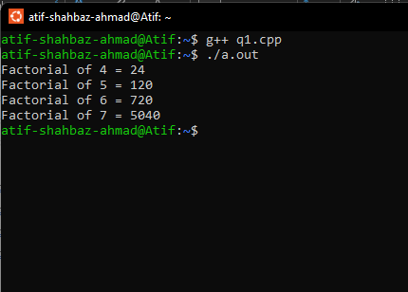

QUESTION # 2
#include <iostream>
#include <pthread.h>
#include <fstream>
using namespace std;

string word;
string file1, file2;

void* search1(void*arg)
{
ifstream file(file1);
string line;
int found = 0;

while (getline(file, line))
{
if (line.find(word) != -1)
{
found = 1;
break;
}
}

if (found)
cout << "String found in: " << file1 << endl;
else
cout << "String NOT found in: " << file1 << endl;

file.close();
return NULL;
}

void* search2(void*)
{
ifstream file(file2);
string line;
int found = 0;

while (getline(file, line))
{
if (line.find(word) != -1)
{
found = 1;
break;
}
}

if (found)
cout << "String found in: " << file2 << endl;
else
cout << "String NOT found in: " << file2 << endl;

file.close();
return NULL;
}

int main()
{
cout << "Enter search word: ";
cin >> word;

cout << "Enter first file path: ";
cin >> file1;

cout << "Enter second file path: ";
cin >> file2;

pthread_t t1, t2;

pthread_create(&t1, NULL, search1, NULL);
pthread_create(&t2, NULL, search2, NULL);

pthread_join(t1, NULL);
pthread_join(t2, NULL);

return 0;
}
OUTPUT
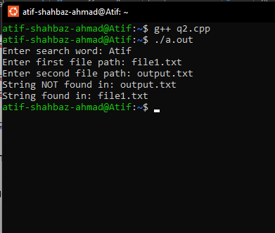

QUESTION # 3
(a) With Deadlock Scenario
#include <iostream>
#include <pthread.h>
#include <unistd.h>
using namespace std;

pthread_mutex_t fork1, fork2, fork3, fork4, fork5;

void* philosopher1(void*)
{
cout << "Philosopher 1 thinking\n";
sleep(1);

pthread_mutex_lock(&fork1);
sleep(1);
pthread_mutex_lock(&fork2);

cout << "Philosopher 1 eating\n";
sleep(2);

pthread_mutex_unlock(&fork2);
pthread_mutex_unlock(&fork1);
return NULL;
}

void* philosopher2(void*)
{
cout << "Philosopher 2 thinking\n";
sleep(1);

pthread_mutex_lock(&fork2);
sleep(1);
pthread_mutex_lock(&fork3);

cout << "Philosopher 2 eating\n";
sleep(2);

pthread_mutex_unlock(&fork3);
pthread_mutex_unlock(&fork2);
return NULL;
}

void* philosopher3(void*)
{
cout << "Philosopher 3 thinking\n";
sleep(1);

pthread_mutex_lock(&fork3);
sleep(1);
pthread_mutex_lock(&fork4);

cout << "Philosopher 3 eating\n";
sleep(2);

pthread_mutex_unlock(&fork4);
pthread_mutex_unlock(&fork3);
return NULL;
}

void* philosopher4(void*)
{
cout << "Philosopher 4 thinking\n";
sleep(1);

pthread_mutex_lock(&fork4);
sleep(1);
pthread_mutex_lock(&fork5);

cout << "Philosopher 4 eating\n";
sleep(2);

pthread_mutex_unlock(&fork5);
pthread_mutex_unlock(&fork4);
return NULL;
}

void* philosopher5(void*)
{
cout << "Philosopher 5 thinking\n";
sleep(1);

pthread_mutex_lock(&fork5);
sleep(1);
pthread_mutex_lock(&fork1);

cout << "Philosopher 5 eating\n";
sleep(2);

pthread_mutex_unlock(&fork1);
pthread_mutex_unlock(&fork5);
return NULL;
}

int main()
{
pthread_mutex_init(&fork1, NULL);
pthread_mutex_init(&fork2, NULL);
pthread_mutex_init(&fork3, NULL);
pthread_mutex_init(&fork4, NULL);
pthread_mutex_init(&fork5, NULL);

pthread_t p1, p2, p3, p4, p5;

pthread_create(&p1, NULL, philosopher1, NULL);
pthread_create(&p2, NULL, philosopher2, NULL);
pthread_create(&p3, NULL, philosopher3, NULL);
pthread_create(&p4, NULL, philosopher4, NULL);
pthread_create(&p5, NULL, philosopher5, NULL);

pthread_join(p1, NULL);
pthread_join(p2, NULL);
pthread_join(p3, NULL);
pthread_join(p4, NULL);
pthread_join(p5, NULL);

return 0;
}
OUTPUT
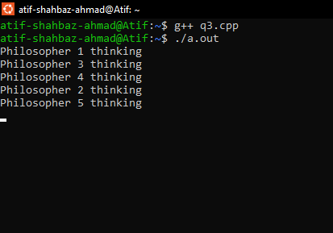

(b)
#include <iostream>
#include <pthread.h>
#include <unistd.h>
using namespace std;

pthread_mutex_t fork1, fork2, fork3, fork4, fork5;

void* philosopher1(void*)
{
pthread_mutex_lock(&fork1);
pthread_mutex_lock(&fork2);
cout << "Philosopher 1 eating\n";
sleep(1);
pthread_mutex_unlock(&fork2);
pthread_mutex_unlock(&fork1);
return NULL;
}

void* philosopher2(void*)
{
pthread_mutex_lock(&fork2);
pthread_mutex_lock(&fork3);
cout << "Philosopher 2 eating\n";
sleep(1);
pthread_mutex_unlock(&fork3);
pthread_mutex_unlock(&fork2);
return NULL;
}

void* philosopher3(void*)
{
pthread_mutex_lock(&fork3);
pthread_mutex_lock(&fork4);
cout << "Philosopher 3 eating\n";
sleep(1);
pthread_mutex_unlock(&fork4);
pthread_mutex_unlock(&fork3);
return NULL;
}

void* philosopher4(void*)
{
pthread_mutex_lock(&fork4);
pthread_mutex_lock(&fork5);
cout << "Philosopher 4 eating\n";
sleep(1);
pthread_mutex_unlock(&fork5);
pthread_mutex_unlock(&fork4);
return NULL;
}

void* philosopher5(void*)
{
// Reverse order
pthread_mutex_lock(&fork1);
pthread_mutex_lock(&fork5);
cout << "Philosopher 5 eating (no deadlock)\n";
sleep(1);
pthread_mutex_unlock(&fork5);
pthread_mutex_unlock(&fork1);
return NULL;
}

int main()
{
pthread_mutex_init(&fork1, NULL);
pthread_mutex_init(&fork2, NULL);
pthread_mutex_init(&fork3, NULL);
pthread_mutex_init(&fork4, NULL);
pthread_mutex_init(&fork5, NULL);

pthread_t p1, p2, p3, p4, p5;

pthread_create(&p1, NULL, philosopher1, NULL);
pthread_create(&p2, NULL, philosopher2, NULL);
pthread_create(&p3, NULL, philosopher3, NULL);
pthread_create(&p4, NULL, philosopher4, NULL);
pthread_create(&p5, NULL, philosopher5, NULL);

pthread_join(p1, NULL);
pthread_join(p2, NULL);
pthread_join(p3, NULL);
pthread_join(p4, NULL);
pthread_join(p5, NULL);

return 0;
}

OUTPUT
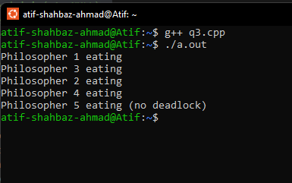

QUESTION # 4
#include <iostream>
#include <pthread.h>
#include <semaphore.h>
#include <unistd.h>
using namespace std;

int queue[3];
int front = 0, rear = 0;

sem_t emptySlots;
sem_t fullSlots;
sem_t mutex;

void* restaurant(void*)
{
for (int order = 1; order <= 5; order++)
{
cout << "Restaurant preparing order " << order << endl;
sleep(2);

sem_wait(&emptySlots);
sem_wait(&mutex);

queue[rear] = order;
rear = (rear + 1) % 3;
cout << "Order " << order << " added to queue" << endl;

sem_post(&mutex);
sem_post(&fullSlots);
}
return NULL;
}

void* driver1(void*)
{
int order;
for (int i = 0; i < 3; i++)
{
sem_wait(&fullSlots);
sem_wait(&mutex);

order = queue[front];
front = (front + 1) % 3;
cout << "Driver 1 picked order " << order << endl;

sem_post(&mutex);
sem_post(&emptySlots);

sleep(1);
cout << "Driver 1 delivered order " << order << endl;
}
return NULL;
}

void* driver2(void*)
{
int order;
for (int i = 0; i < 2; i++)
{
sem_wait(&fullSlots);
sem_wait(&mutex);

order = queue[front];
front = (front + 1) % 3;
cout << "Driver 2 picked order " << order << endl;

sem_post(&mutex);
sem_post(&emptySlots);

sleep(1);
cout << "Driver 2 delivered order " << order << endl;
}
return NULL;
}

int main()
{
pthread_t r, d1, d2;

sem_init(&emptySlots, 0, 3);
sem_init(&fullSlots, 0, 0);
sem_init(&mutex, 0, 1);

pthread_create(&r, NULL, restaurant, NULL);
pthread_create(&d1, NULL, driver1, NULL);
pthread_create(&d2, NULL, driver2, NULL);

pthread_join(r, NULL);
pthread_join(d1, NULL);
pthread_join(d2, NULL);

cout << "All orders delivered.." << endl;
return 0;
}

OUTPUT
